**MODELLING THE ROCK CYCLE USING CRAYONS**

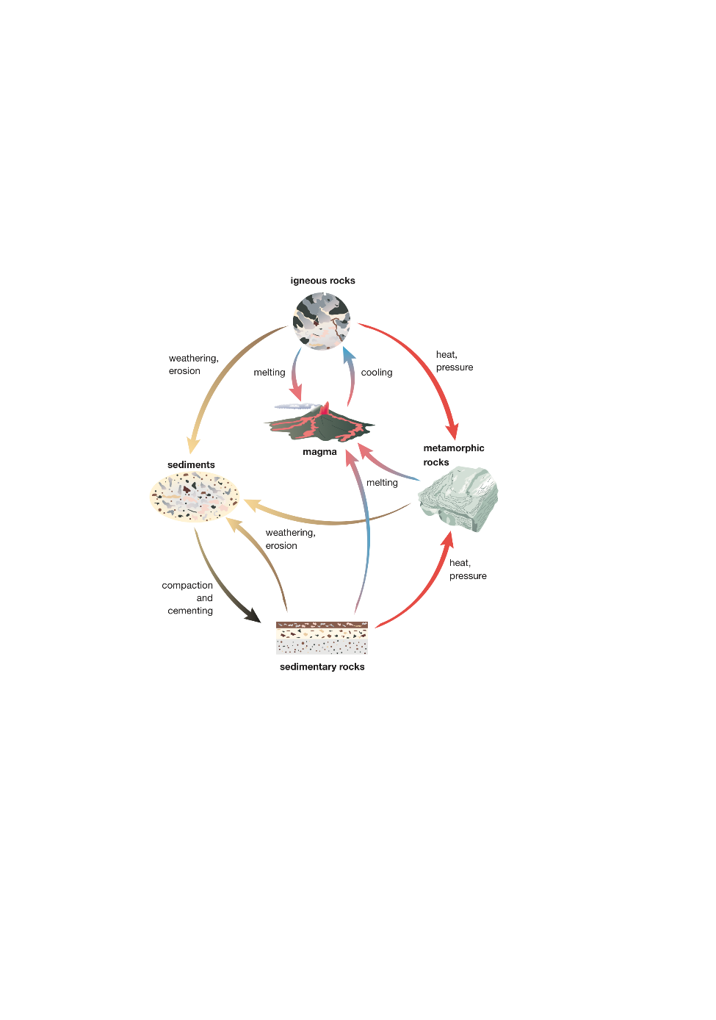

**Background:**

The rock cycle describes the continuous processes that break down and form the three rock types- igneous, sedimentary and metamorphic.

Igneous rock is formed by the cooling and hardening of magma.

Sedimentary rock is formed through weathering and erosion, deposition, compaction, and cementation of rock fragments.

Metamorphic rock is formed by great heat and pressure on a rock that causes it to change form into a metamorphic rock.

**Aim:** To model the processes in the rock cycle using crayons

**Vocabulary:** heat, temperature, rock cycle, igneous rock, sedimentary rock, metamorphic rock, solid, liquid, molten, weathering, erosion, sediments, layering, compaction, cementing

**Materials:**

* 3 crayons (different colours)
* Grater
* 2 plastic cups
* 400mL beaker
* Hot/boiling water
* Newspaper to cover work area

**Method:**

* 1. Remove the paper from one crayon and grate the crayon.
  2. Transfer the grated crayon into one of the plastic cups.
  3. Grate the second crayon and transfer it into the plastic cup, forming a layer top of the first grated crayon. Repeat with the third crayon.
  4. Place the second plastic cup inside the cup with the layers of grated crayon and gently press down on the cup to compact the crayon.
  5. Fill the beaker with boiling water and sit the cup with the grated crayon in the hot water.
  6. Fill the empty plastic cup with boiling water and place it inside the cup with the crayon.
  7. Leave for 10 minutes and then remove from the hot water and allow to cool.
  8. When cool, remove the solidified crayon from the plastic cup.

**Observations and Questions:**

1. Describe the crayons.
2. What type of rock does the crayon represent?
3. What type of weathering (physical, biological or chemical) took place? Explain your choice.
4. What term is used to describe the movement of the sediment piles of grated crayons into the plastic cup?
5. What type of rock did you form at step 4?
6. Describe what your rock looked like at this stage.
7. What type of rock did you form in step 8?
8. Describe what your rock looked like at this stage.
9. Complete the table to show what each part of the model represented in the rock cycle

*Metamorphic rock compaction and cementing igneous rock heat and pressure weathering and erosion sediments sedimentary rock*

|  |  |
| --- | --- |
| Process of the lab activity | Part of the rock cycle |
| Original crayon |  |
| Grating the crayons |  |
| Pile of grated crayon layered in cup |  |
| Pushing on the pile of crayon with another cup |  |
| Placing the cup and grated crayon in hot water |  |
| Cooled crayon removed from the cup |  |

1. Complete the Venn diagram to show the similarities and differences between your three rocks.

Sedimentary

Igneous

Metamorphic